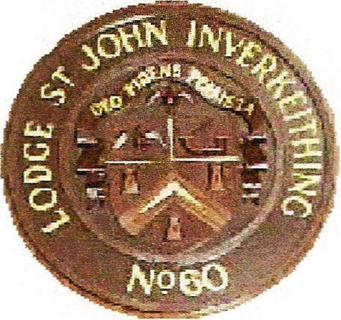
Charter Granted is" November 1754
Contacts:
Alex Ramage: 07733 129289
William Galloway: 07740 575293

Hire Of Hall
Booking Form

Lodge St John No. 60
The Masonic Hall
17 Hope Street
Inverkeithing
Fife

Fee: £80 to be paid at time of booking
Name:
Address:
Tel No.
Date/Time of Function @ PM
Type of Function ie birthday, anniversary etc, _
Approx Numbers A list of Guest will be required
Have you booked a Band or Disco _Yes/No _(delete as required)
Band/Disco equipment must be removed immediately after the function,
unless previously arranged.
Buffet Table required _ Yes/No_
Entry to hall for Decorating/Setting Up, Buffet etc will be 1 hour before
function.
No Party Poppers Please

FOR LODGE USE ONLY
BAR STAFF
Barmen
Glass Washers

